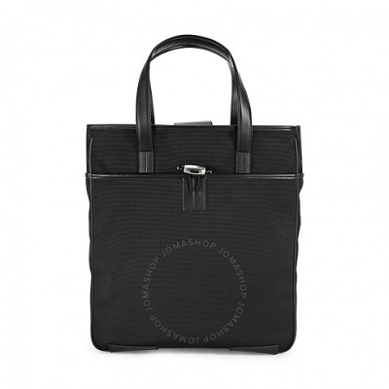

Montblanc Night Flight Vertical Tote Bag

PRODUCT DETAILS

**Montblanc Night Flight Vertical Tote Bag. Exterior front compartment, exterior back compartment. 1 Interior zip pocket, 2 interior slit pockets, 1 Pocket for writing instrument. H: 14.5in. x W:13.5in. Handle Drop:7 in. Made in Italy.**